Follow the below Procedure to access Oracle database.
- Open SQL developer IDE tool
- Click on plus button on connection panel which is in left side.
- Enter necessary details in the New Database Connection window
  - Connection Name : your wish/any name
  - Hostname : Oracle02
  - Username : Training
  - Password : syntel123
  - SID : Xe
- Click on test button to check connection successfully or not
- If connection status is success, then click on save button to save the connection
- connection name is available on left panel

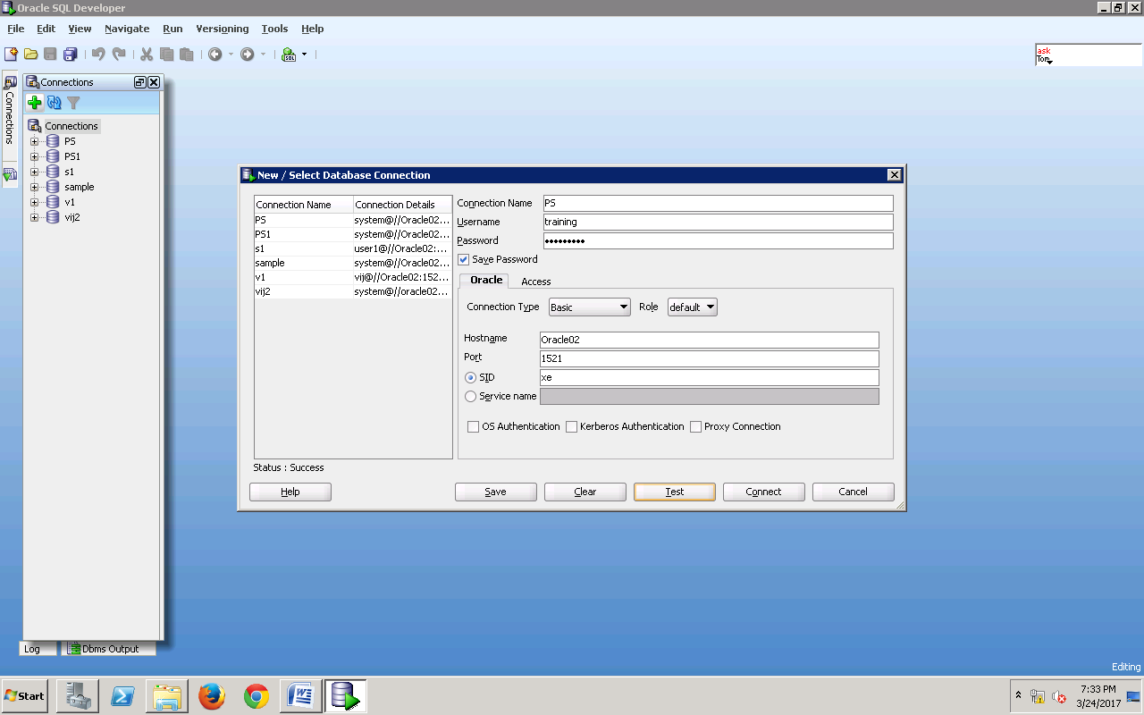
The below tables were created with sample rows for completing below exercise.
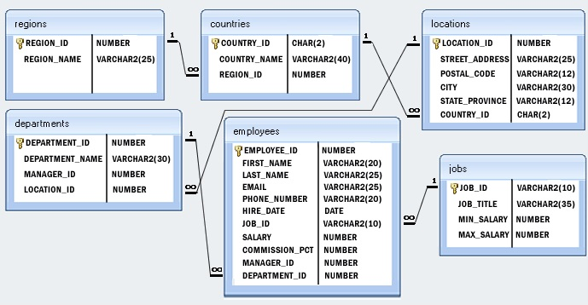
One Region can have multiple countries.
One County can have multiple locations.
One Location can have multiple departments.
One department can have multiple employees.
One employee belongs to only one job. Multiple employees belongs to same job also.
DCL Exercise :
1) Open New Connection using training user account name it as screen1.
2) Create a new user account for your LAN ID. Execute this on Screen 1
3) Change the Password of your account. Execute this on Screen 1
4) Open New Connection using training user account name it as screen2.
5)Grant Create Session Permission to new User. Execute this on Screen 1
6) Open New Connection using training user account name it as screen2.
7) Retrieve all records from training. Employee table. Execute this on Screen 2
8) Grant DML,DQL permission on training. Employees table to new user for accessing it. Execute this on Screen 1
9) Retrieve all records from training. Employees table. Execute this on Screen 2
10) Revoke DQL permission on training. Employees table to new user.
11) Retrieve all records from training. Employees table. Execute this on Screen 2
12) Grant DML,DQL permission on training. Regions table to new user for accessing it. Execute this on Screen 1
13) Grant DML,DQL permission on training. Countries table to new user for accessing it. Execute this on Screen 1
14) Grant DML,DQL permission on training. Locations table to new user for accessing it. Execute this on Screen 1
15) Grant DML,DQL permission on training. Jobs table to new user for accessing it. Execute this on Screen 1
16) Grant DML,DQL permission on training. Departments table to new user for accessing it. Execute this on Screen 1
17) Grant DML,DQL permission on training. Employees table to new user for accessing it. Execute this on Screen 1
18) Grant DML,DQL permission on training. Job_history table to new user for accessing it. Execute this on Screen 1
19) Grant DBA permission to new user. Execute this on Screen 1
20) Create another user account name it as temp
21) drop the account named as temp.

DDL Exercise :
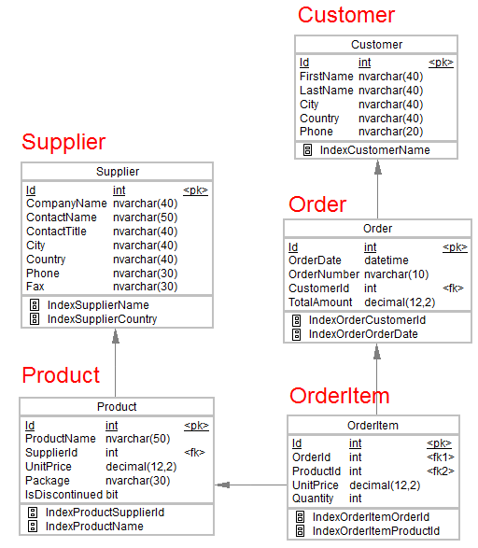
1) Create above tables with respective columns and relationships.
2) Create table named as MobileUser. which has two columns userid, username. here userid should be a primary key.
3) Create table named as ProfileUpload. which has three columns imageId,pixel,whouploadit.
4) Add these constraints after table is created. imageId should be a primary key and whouploadit should be a foreign key.
5) here user can have only one profile photo and others should not use same profile picture. use proper relationship between these table accordingly.
6) Create table named as . which has two columns bookid, bookname. here bookid should be a primary key and bookname should be unique.
7) Create table named as BookCoverUpload. which has three columns imageId, pixel, whichbook.
8) Add these constraints after table is created. bookId should be a primary key and whichbook should be a foreign key use Cascade.
9) A book can have multiple cover photos and other books should not use same cover. use proper relationship between these table accordingly.
10) Create table named as NewsPaper. which has two columns newsid, newsname. here newsid should be a primary key.
11) Create table named as NewsPhoto. which has three columns newsphotoId, pixel, whichnews.
12) Add these constraints after table is created. NewsId should be a primary key and whichnews should be a foreign key use SetNull.
13) A news can have multiple photos and other news can use same photos. use proper relationship between these tables accordingly.

DML Operations:
Insert below sample records to the above created tables.
MobileUser
userid | username
M101 | Smith
M102 | Steve
M103 | Jhon
M014 | George
M105 | July
ProfileUpload
imageId |  | pixel |  | whouploadit
P1001 |  | 600*800 |  | M101
P1002 |  | 600*800 |  | M102
P1003 |  | 600*800 |  | M103
P1004 |  | NULL |  | M104
P1005 |  | NULL |  | M105
P1006 |  | 600*800 |  | M105 |  | This record should not be able to inserted

Book
bookid | bookname
M101 | Smith
M102 | Steve
M103 | Jhon
M014 | George
M105 | July

BookCoverUpload
ImageId |  | pixel |  | whichbook
P1001 |  | 600*800 |  | M101
P1002 |  | 600*800 |  | M102
P1003 |  | 600*800 |  | M103
P1004 |  | 600*800 |  | M104
P1005 |  | 600*800 |  | M105
P1006 |  | 600*800 |  | M105
P1006 |  | 600*800 |  | M104 | This record should not be able to inserted
NewsPaper
newsid | newsname
M101 | Smith
M102 | Steve
M103 | Jhon
M014 | George
M105 | July

NewsPhoto
newsphotoId | pixel
P1001 | 600*800
P1002 | 600*800
P1003 | 600*800
P1004 | 600*800
P1005 | 600*800
P1006 | 600*800

NewsPaperPhotos
newsid | newsphotoId
M101 | P1001
M101 | P1002
M102 | P1001
M102 | P1002
M101 | P1002 | This record should not be able to insert the record

1) insert above rows in the respective tables.
2) update pixel to 1200*1200 on profileUplaod table who is userId is M101.
3) Delete userid M103 from MobileUser table.
4) Delete book M103 from MobileUser table.
5) Delete newsPaper M103 from MobileUser table.

DQL Exercise
1) retrieve all the rows and columns from countries table
2) retrieve only country name column from countries table
3) retrieve only country name column with customized column heading as 'Country'' from countries table
4) retrieve employees records from employee table who is employee id is 101
5) retrieve employees records from employee table whose is employee id range between 101 and 120
6) retrieve employees records from employee table whose is salary greater than 5000.
7) retrieve employees records from employee table whose is salary lesser than 5000.
8) retrieve employees records from employee table whose jobids are ST_MAN, ST_CLERK,SA_REP.
9) retrieve employees records from employee table whose name starts from Oli.
10) retrieve employees records from employee table whose name ends with thy.
11) retrieve employees records from employee table whose name p(don't know middle letter)t.
12) retrieve all Job Ids from employee table and display without duplicate
13) retrieve all employee records from employee table and order by job_Id,Salary
14) Show how many employees are working each Job_Id
15) Show min salary of each department
16) Show max salary of each department
17) Show average salary of each department which is grater than 10000.00
18) Show Employee First Name, Last Name, Department Name using Join
19) Show Region Name, Country Name, City, First name, Last Name using Join
20) Retrieve Employee Id, First Name, Last Name from employee table whose employee id is between 100 and 200 and copied into new table named as EmployeeBackUp.
21) Add Five more records into EmployeeBackUp Table.
Employee_Id | First_Name | Last_Name
300 | A | B
301 | C | D
302 | E | F
303 | G | H
304 | I | J
305 | K | L
22) Display Common records from Employees and EmployeebackUp table.
23) Display records only present in Employees table and not in EmployeebackUp table.
24) Display all records present in Employees and EmployeebackUp table without duplication.
25) Display all records present in Employees and EmployeebackUp table with duplication.
26) Display FirstName and Last Name of employees who are working in IT Support department.
27) Display FirstName and Last Name of employees who are working in Sales department and SA_MAN Job Id.
28) Create Sequence and display 10 values generated by it.
29) Create View named as EmployeeView for fetching Employee First Name, Last name , Employee Id , Salary from employees table and access them using view name.
30) Create indexing above mentioned tables in DDL statements.

